COURSE CODE: PGD002

COURSE NAME: POST GRADUATE DIPLOMA IN WATER HYGIENE AND SANITATION

**WASH Monthly Assignment 2**

**By Vakhtang Kochoradze**

**30.09.2018**

**Assignment**

1. Consider a disease known as diabetes mellitus, which is characterized by an increase in the blood sugar level. Infectious agents may contribute to the development of the disease in early childhood, but are not the main cause of the disease. Can it be classified as communicable? Explain your reasons

Diabetes mellitus in itself is a non-communicable disease (NCD) as it is mainly a result of a combination of genetic, physiological, environmental and behavioral factors (WHO, 2018). When we are considering the effects of an infectious agents, they serve the main basis for communicable diseases to occur (WASH Module 2 Notes). However, if the infectious agent becomes a contributor to the NCD it becomes a risk factor. The role of the infectious agent could be a development of a disease, an NCD or communicable disease, which can lead to Diabetes. Therefore making a divide between NCDs and communicable diseases is difficult to make, as communicable diseases often do lead to the development of NCDs (WHO, 2013).

Diabetes mellitus itself is not a communicable disease, but the infectious agent, as well as other contributing factors, such as a bad diet, polluted environment, etc. are subject to mitigation for the disease not to take place.

1. How would you classify pulmonary tuberculosis using the epidemiologic method? What is the main importance of such classification?

Pulmonary tuberculosis is caused by a bacteria called Mycobacterium tuberculosis (M tuberculosis), which is contagious and is spread through air droplets produced by the infected source (US National Library of Medicine, 2018). Therefore we can conclude that the mode of transmition of the disease is through air, making it an airborne disease (WASH Module 2 Notes)

Epidemiologic method is a way of classifying communicable diseases through differencing their modes of transmission. If we assess the importance of public health as a meter of policy evaluations, how the resources are to be allocated of what type of interventions are to be made (Savitz D., 1999), it can be said that epidemiological classification plays an important role for public health officers/pratctitioners for establishing modes of operation in public health as epidemiologic method is a tool for analyzing and identifying what measures need to be taken to prevent or control various types of diseases. In addition, in case of an epidemical outbreak for example, such a method (among other methods) will be of vital importance to establish clusters and disease patterns (CDC, 2009).

1. Describe four or more bacterial vaccine-preventable diseases that have the same modes of transmission.

|  |  |  |  |  |  |
| --- | --- | --- | --- | --- | --- |
| # | Cause | Mode of Transmission | Epidemiologic classification | Symptoms | Vaccination |
| 1. Diphteria | Corynebacterium diphtheria and its toxins | Indirect | Airborne diseases: transmitted through the air. | The disease transmits from person to person through air droplets produced by cough of sneeze. It causes high fever, airway blockage, cardiovascular damage and more. | DTaP |
| 1. [Pertussis](http://www.cdc.gov/pertussis/) | Bordetella pertussis bacteria | Indirect | Airborne diseases: transmitted through the air. | The disease transmits from person to person through air droplets produced by cough of sneeze. It causes rapid coughs that can result in fractured rib cage, vomiting and exhaustion. | DTaP |
| 1. Tetanus | Clostridium tetani bacteria | Indirect | Vehicle-borne diseases: transmitted through cuts or damaged skin via physical contact with contaminated objects | The disease causes arterial blockage, pneumonia, and difficulty breathing, uncontrollable sweating, seazures, muscle spasms, and more. | DTaP |
| 1. Influenza | Orthomyxoviruses | Indirect | Airborne diseases: Exposure through coughing, sneezing, or speaking | Fever, coughing, diahhrea, headaches and more | Trivalent flu vaccines |

Source: Public Health, 2018

1. What are the causes and methods for preventing bacterial meningitis?

Bacterial Meningitis is the most serious form of all meningitis types that also include viral and fungal. The disease starts the effect in about five hours which includes high fever, neck stiffness, seizures, loss of consciousness, increased heart rate, strong headache, vomiting, and more. The mode of transmission of Meningitis is indirect and is an airborne disease, generally contracted via droplets through coughing and sneezing (WASH Module 2 Notes). The infection occurs when the meninges, which are the membranes that cover the spinal cord and brain when become inflamated through infection (CDC, 2017). Generally, meningitis is found in children, but adults who have compromised immune systems can be affected as well (WASH Module 2 Notes). If the disease is not treated, it can cause death or permanent physical damage (For ex. Brain Damage) (ibid).

Meningococcal meningitis is caused by the meningococcus bacteria Neisseria meningitides bacteria, which is classified into twelve types, out of which, six (A, B, C, W, X and Y) cause epidemic outbreaks (WHO, 2018; WASH Module 2 Notes). The largest outbreaks of meningitis occurs in what is called the sub-Sahara, which is also know as the Meningitis belt (ibid). The transmission of the bacteria happens in mass gatherings, condensated housing conditions, proximity living with carriers, etc (ibid).

The prevention of the disease can happen through either decreasing the risk factors (as listed above) associated with meningitis or through vaccination. However, there is no universal vaccination that can prevent all meningitis types from happening. The vaccines are type specific and are limited in how long the active effects are too last (WHO, 2018). Another way of prevention is to administer Antibiotic prophylaxis, an antibiotic which is administered when in close contact with possible hosts (ibid).

1. Explain two characteristics that illustrate how the Anopheles larvae are different from other mosquito larvae. Using illustration is advised

There are two very distinct characteristics that distinguishes the Anopheles larvae from other mosquitos. 1) Anopheles larvae do not have a respiratory siphon and therefore 2) they position themselves in parallel to water.

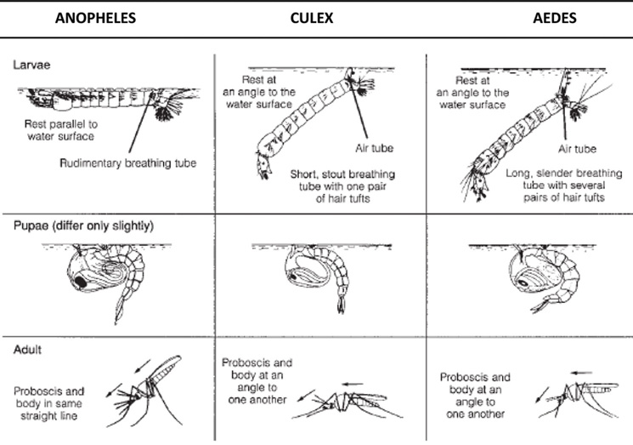

Source: OpenLearn Create

**References**

Center for Disease Control and Prevention (CDC), 2009, Meningitis. Retrieved from <https://www.cdc.gov/meningitis/index.html>.

Center for Disease Control and Prevention (CDC), 2009, Salmonella. Retrieved from <https://www.cdc.gov/salmonella/2009/peanut-butter-2008-2009.html>

OpenLearn Create, 2018,  Distinguishing Anopheles mosquitoes from other types. Retrieved from <http://www.open.edu/openlearncreate/mod/oucontent/view.php?id=88&section=20.8>

PublicHealth.org, 2018, CDC-Recommended Vaccinations. Retrieved from <https://www.publichealth.org/public-awareness/understanding-vaccines/cdc-recommended-vaccinations/>.

Savitz D, Poole C, Miller WC. Reassessing the role of epidemiology in public health. Am J Public Health. 1999;89(8):1158–1161. doi: 10.2105/AJPH.89.8.1158

US National Library of Medicine, 2018., Pulmonary tuberculosis: MedlinePlus Medical.  Retrieved from <https://medlineplus.gov/ency/article/000077.htm>

# World Health Organisation, 2013., Communicable Diseases Newsletters. Retrieved from <http://www.searo.who.int/about/administration_structure/cds/newsletters_may_2013/en/>

World Health Organisation, 2018, Non communicable diseases. Retrieved from <http://www.who.int/news-room/fact-sheets/detail/noncommunicable-diseases>

World Health Organisation, 2018., Meningococcal meningitis. Retrieved from <http://www.who.int/news-room/fact-sheets/detail/meningococcal-meningitis>.